

ADBMS LAB

Prof. Swati Ahirrao



CS 15-19

Saurabh Shingte

15070121160

Lab Assignment - 1

1. Write and Implement PL/SQL code to swap two numbers.

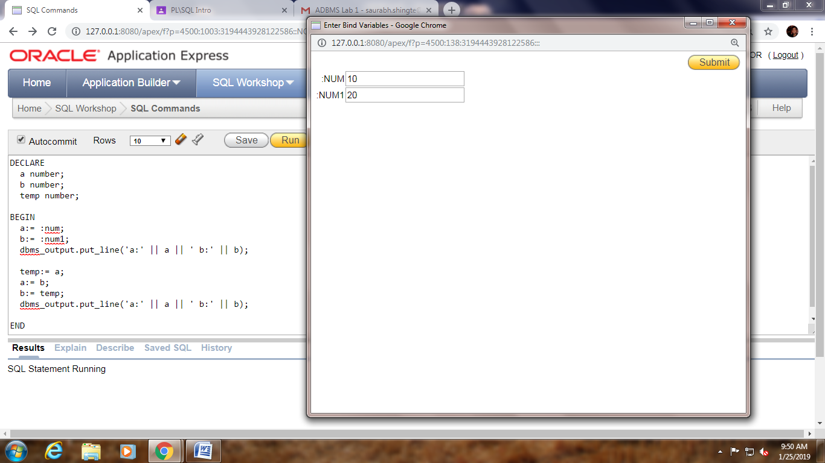

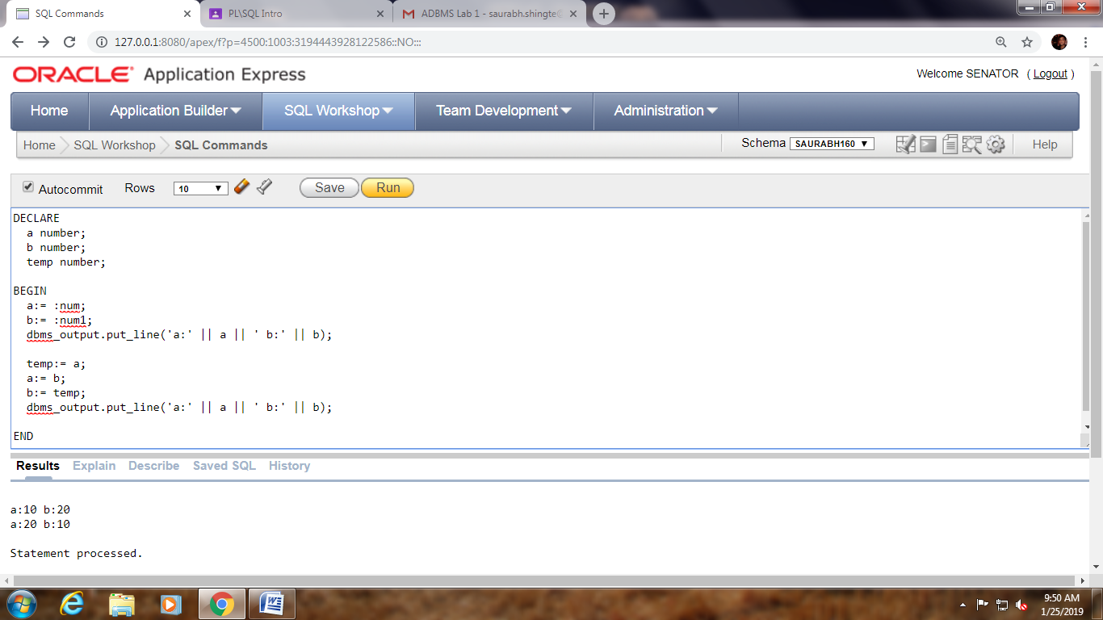

2. Write and implement PL/SQL code to find student’s first name and last name from student table and print it on the screen.

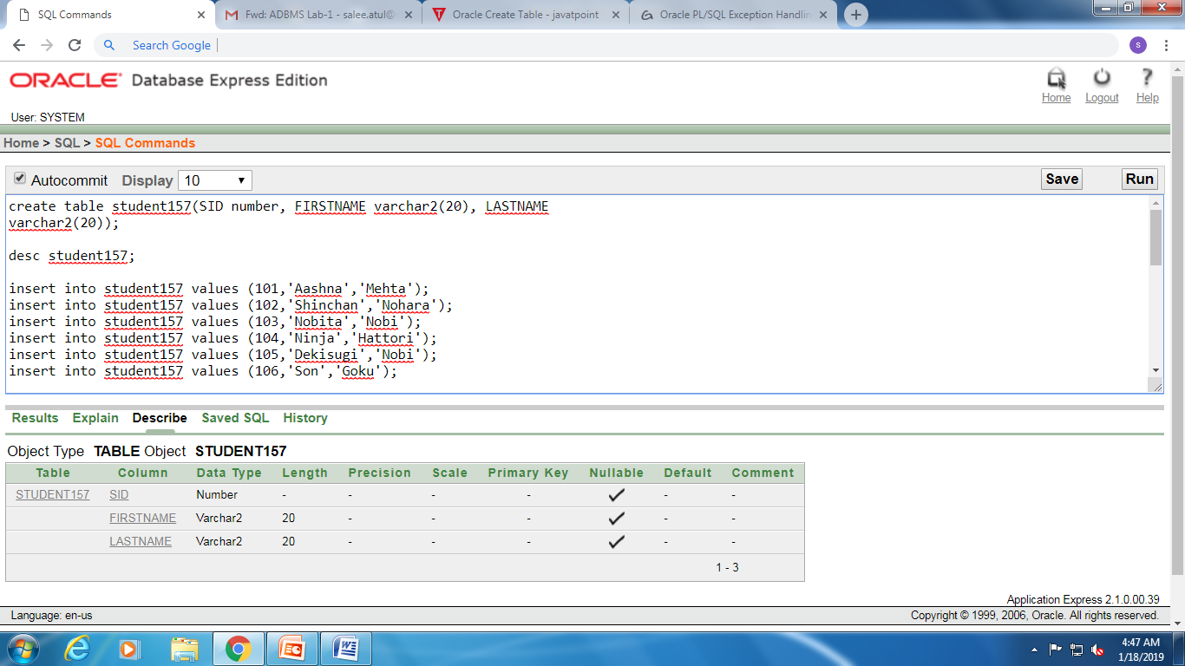

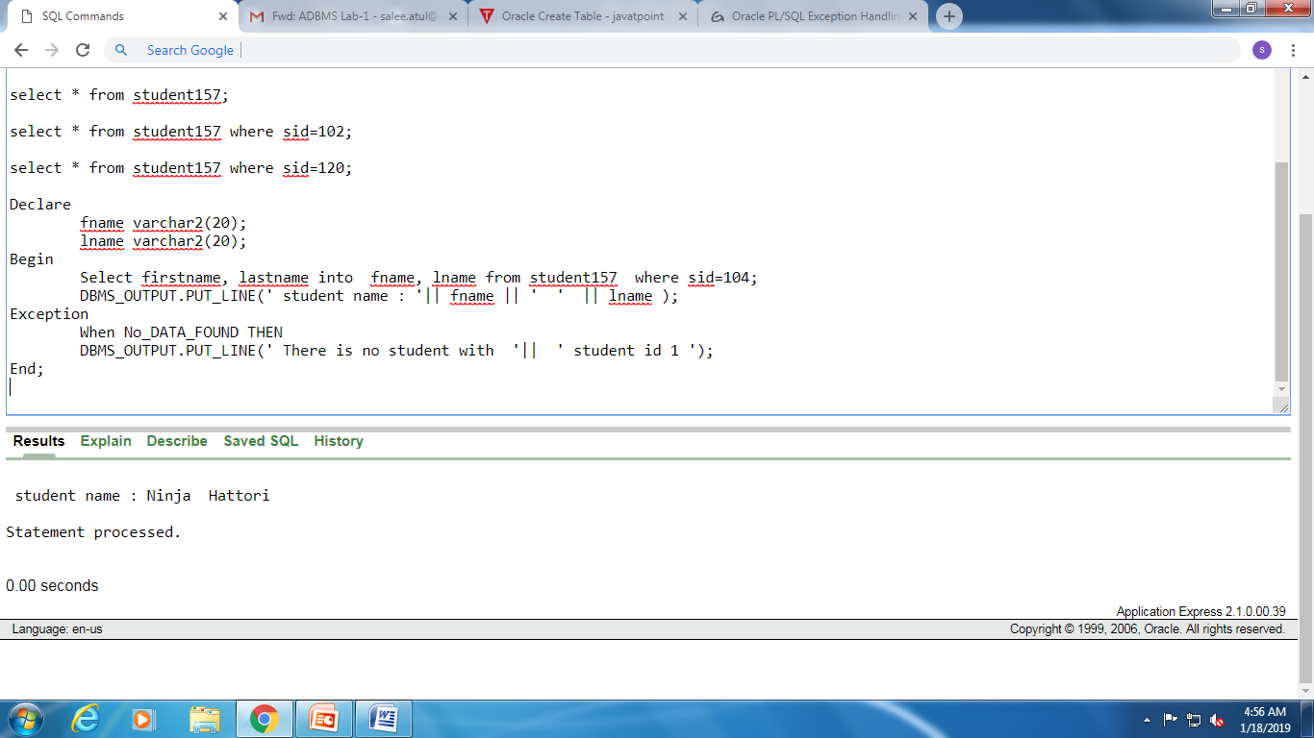

3. Write and implement PL/SQL code to calculate power of the number.

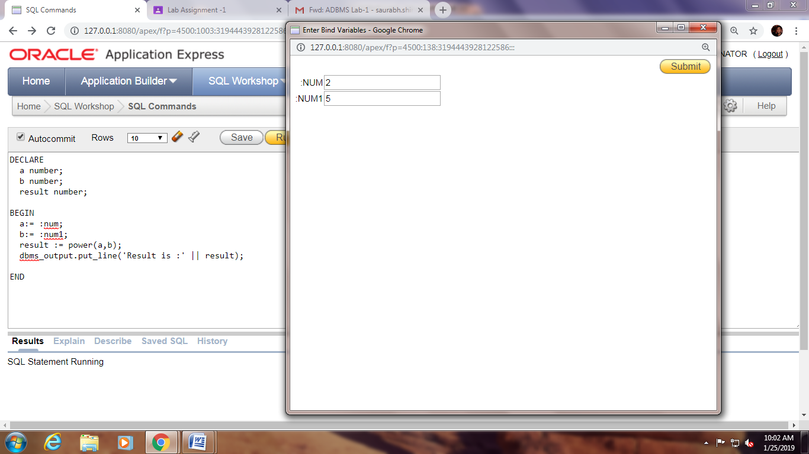

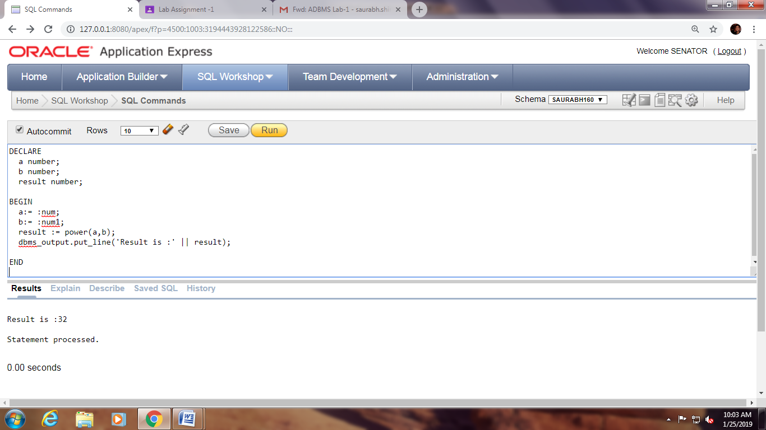

4. Write and implement PL/SQL code to determine day of week based on today's date.

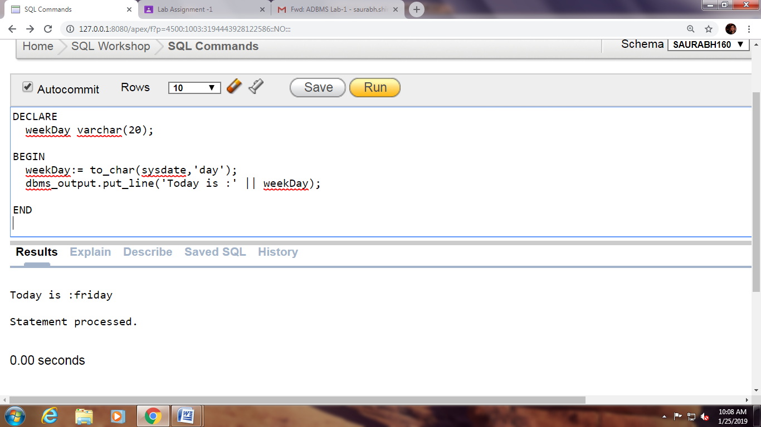

5. Write and Implement PL/SQL code to print number 10 to 5 using simple

loop, while loop and for loop.

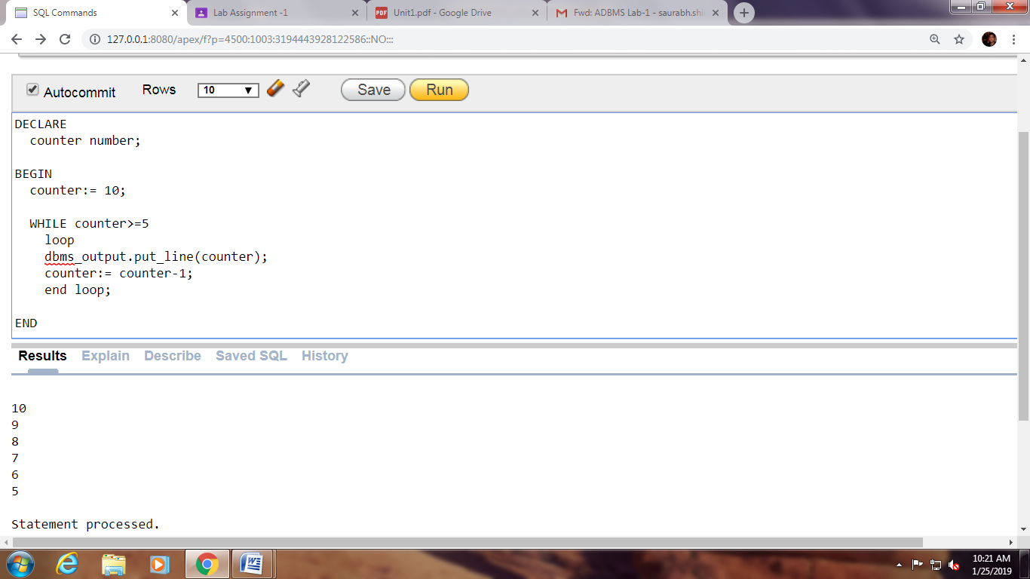

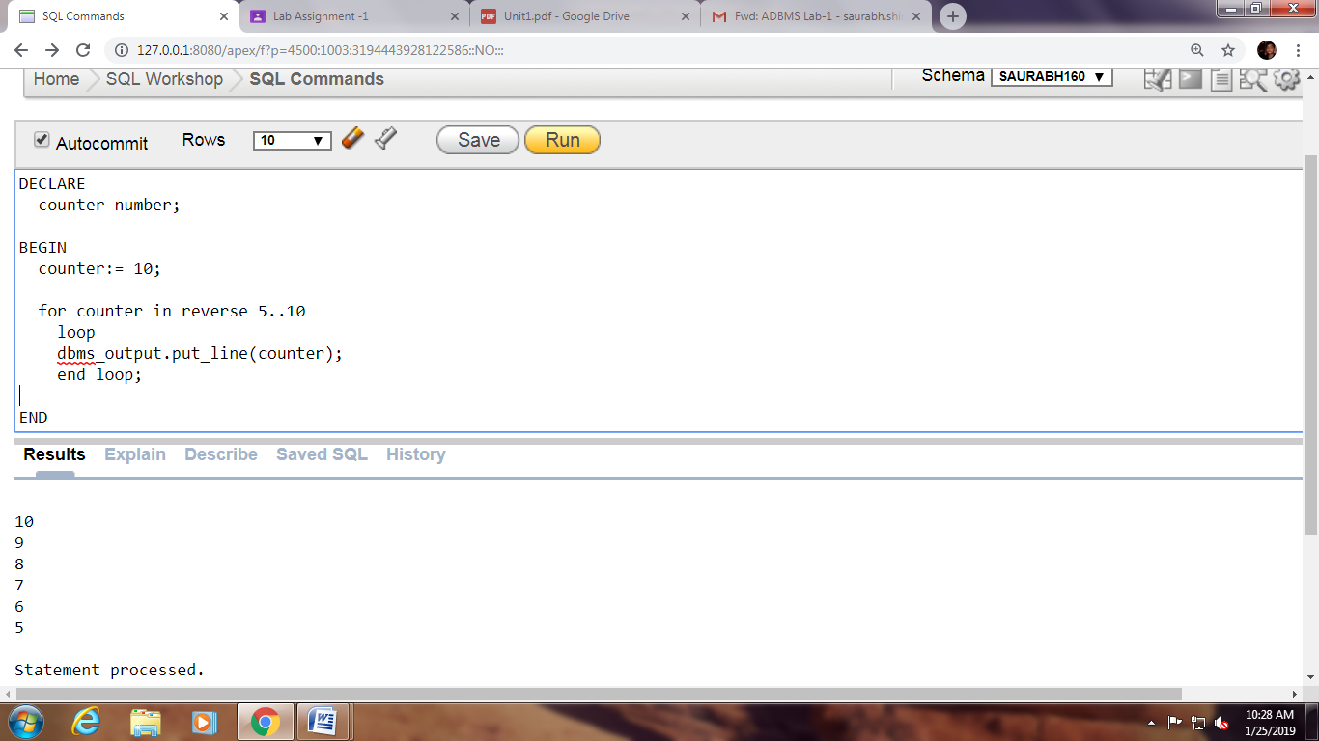

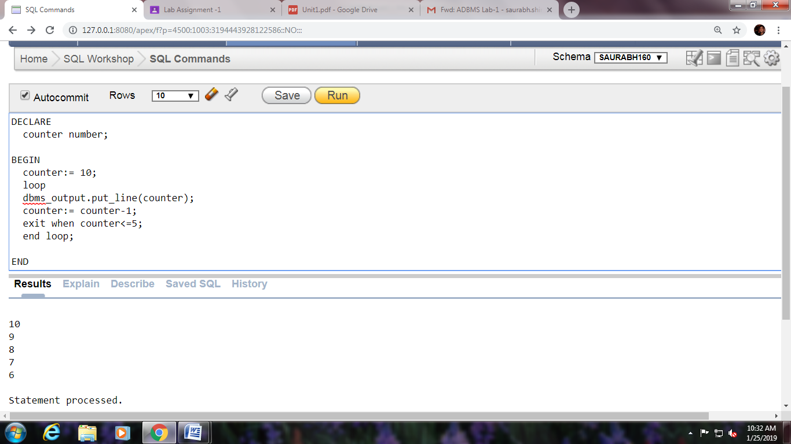

6. Write and Implement PL/SQL code to print the given number is even or odd.

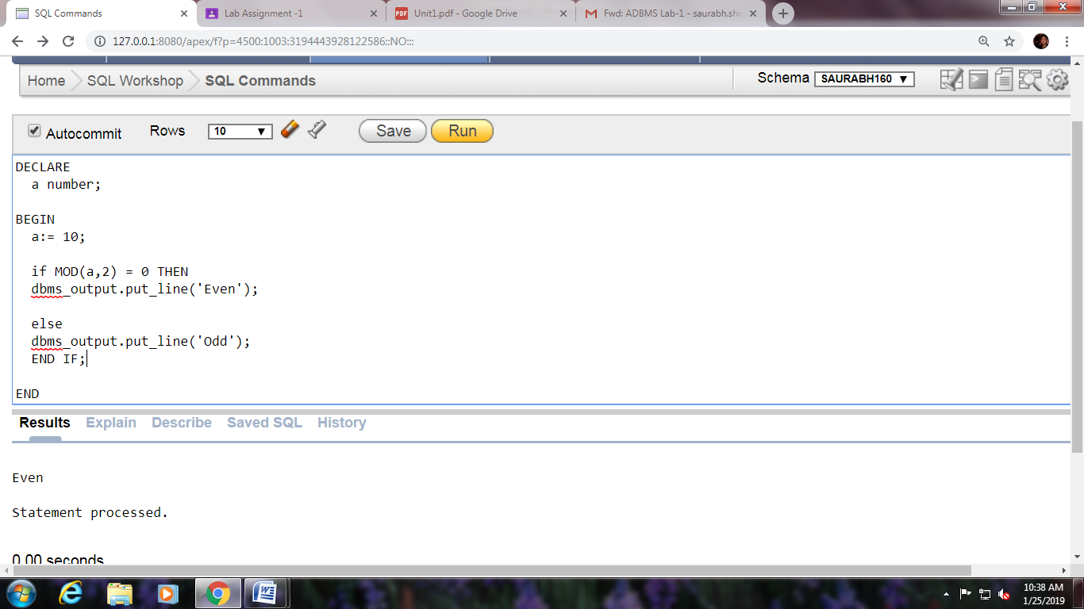

7. Write and Implement PL/SQL code to find factorial of the number.

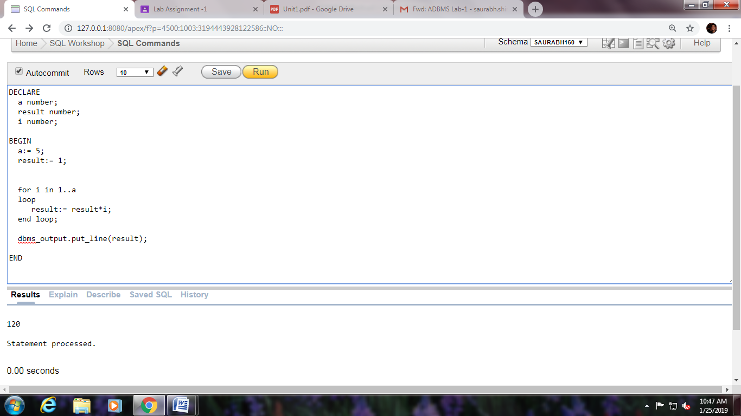

Lab Assignment – 2

1. Write and Implement PL/SQL code to display customer name and address of a given customer from customer table. If the customer Id is not present in the table, it should throw an exception (‘no such customer’).

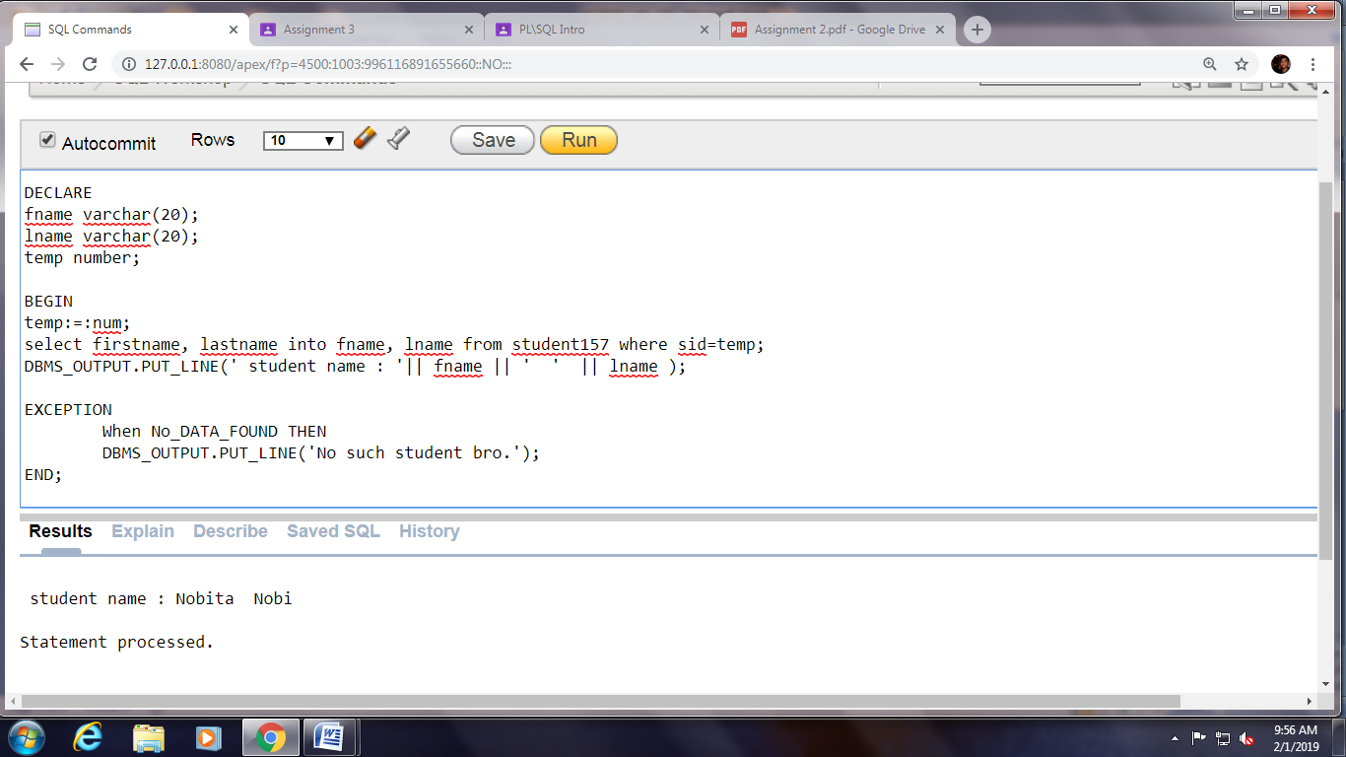

1. Write and Implement PL/SQL code to display customer name and address of a given customer from customer table. When customer id is less than or equal to zero, it should throw user defined exception (‘Id must be greater than 0’).

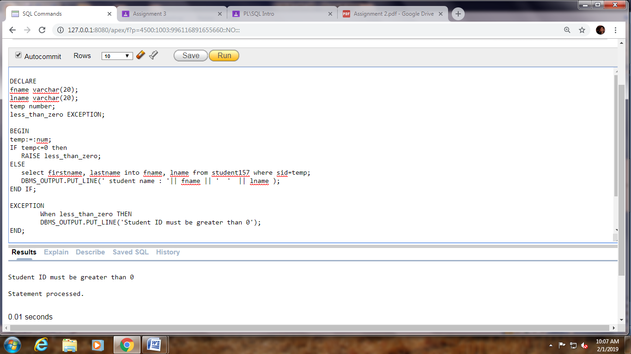

1. Write and Implement PL/SQL code to find Length when Area and breadth of a Rectangle is given. If breadth is zero, it should throw an exception (zero_divide).

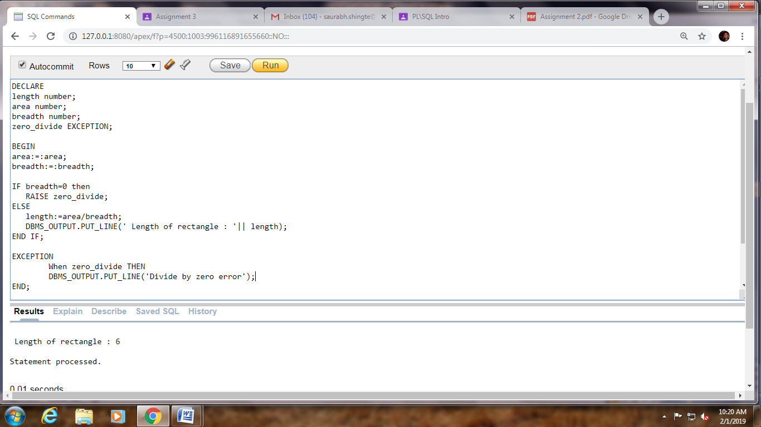 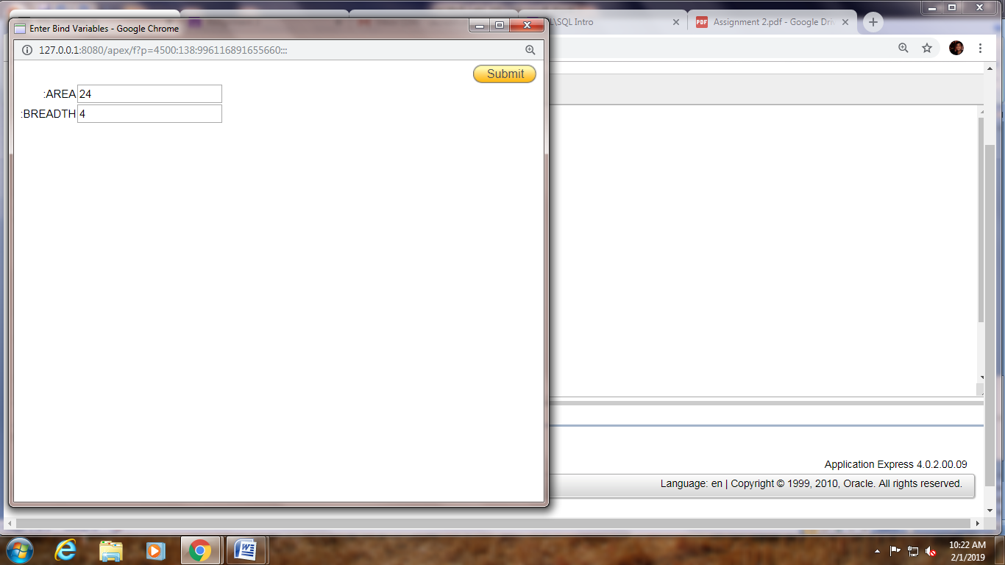

1. Write and Implement PL/SQL code to raise the marks of a given student (sid) by 10 %. If no data found it should throw exception (NO_Data_found). If the marks are null , it will raise_application_error(20101, 'Mark are missing').

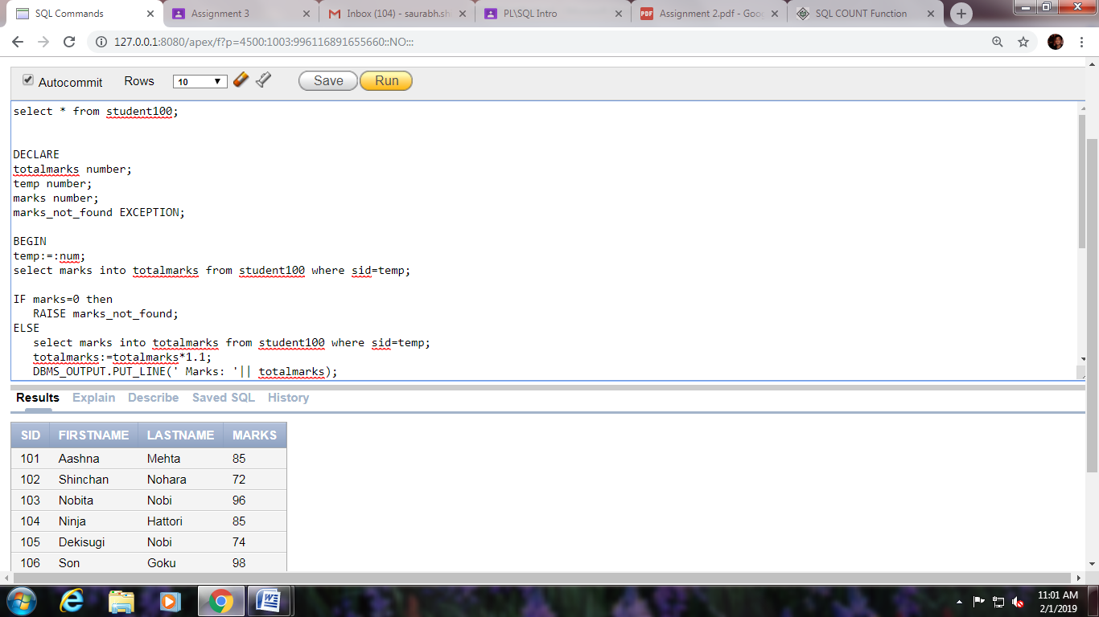

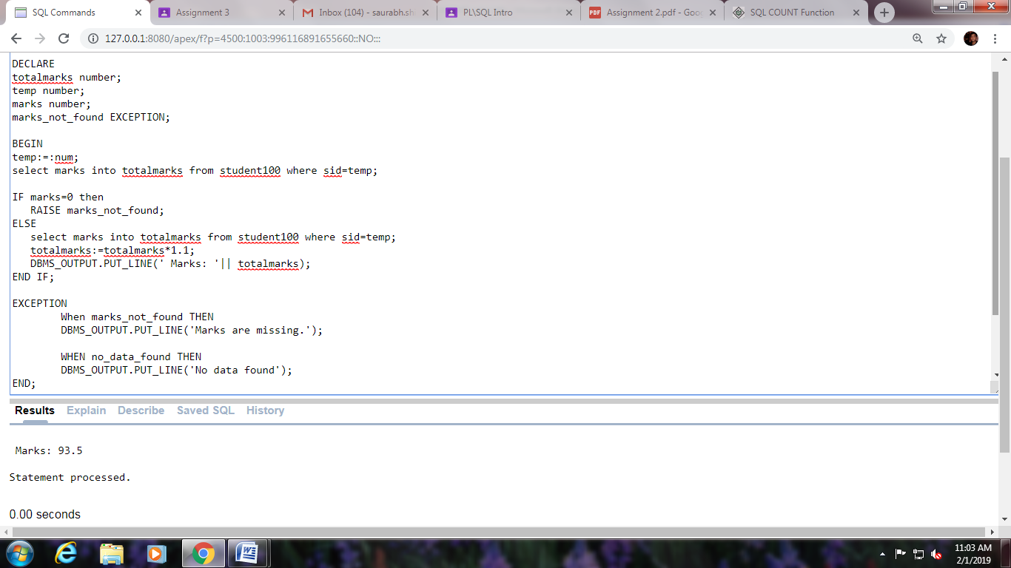

Lab Assignment – 3

1. Write a PL/SQL function to check if a number is prime or not.

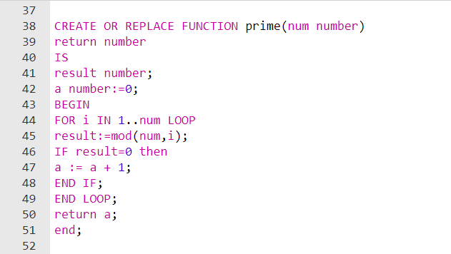

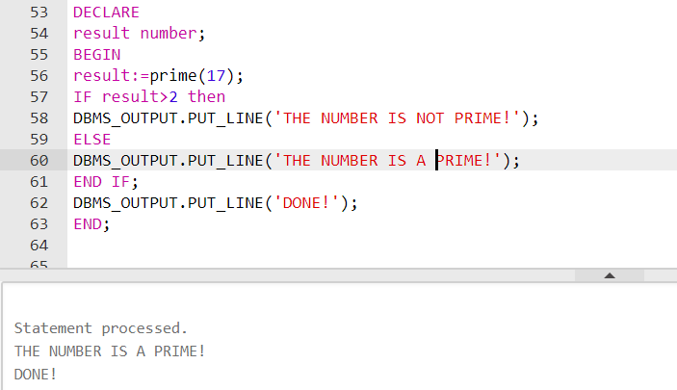

2. Write a PL/SQL function to find the sum of the 1st 100 even numbers.

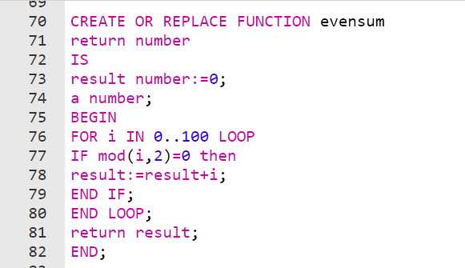

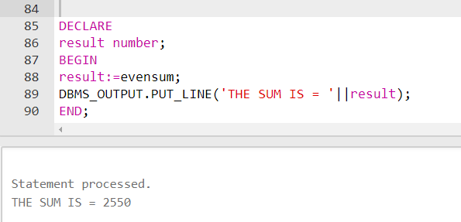

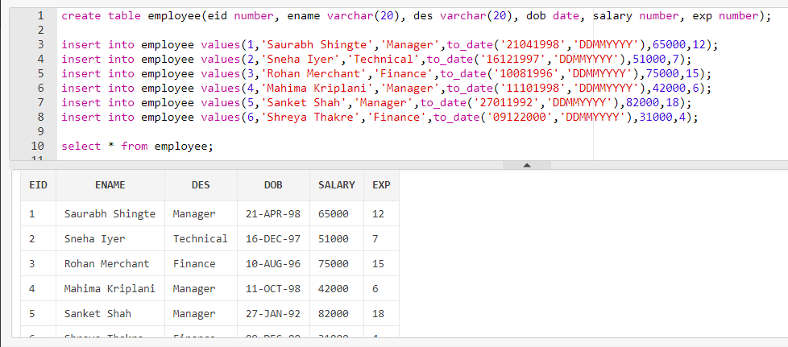

3. Create a function to find out total number of employees in a table.

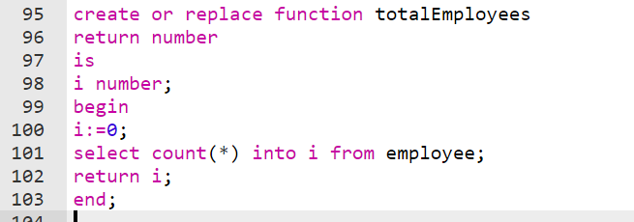

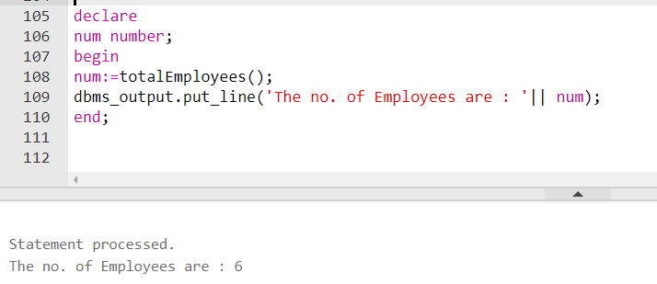

4. Create a function to find Employee ID of employee having the highest salary.

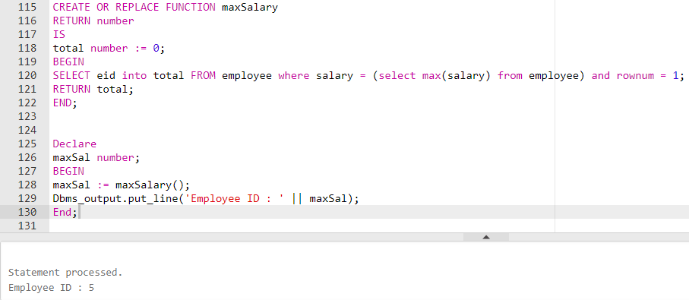

1. Create a function to find the number of employees having salary greater than 60000.

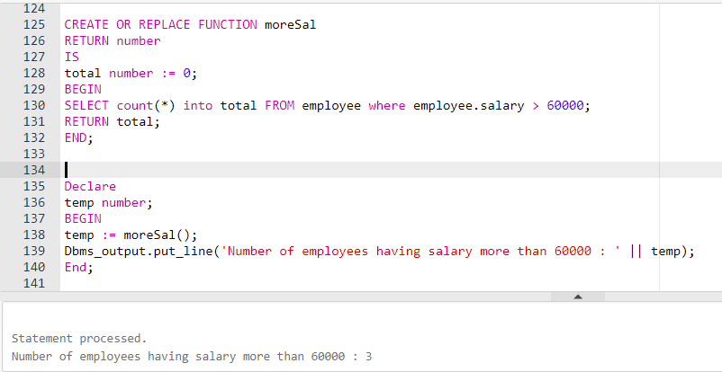

Lab Assignment – 4

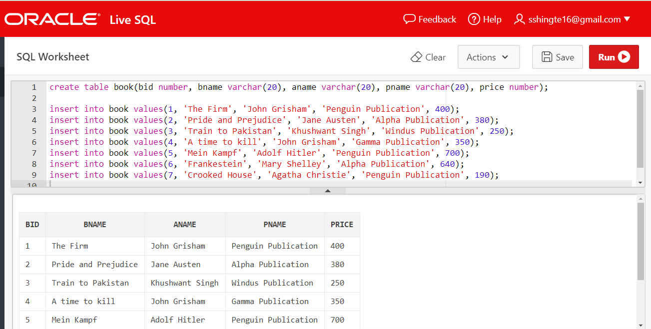

1. Write a procedure to find the details of books of a given library.

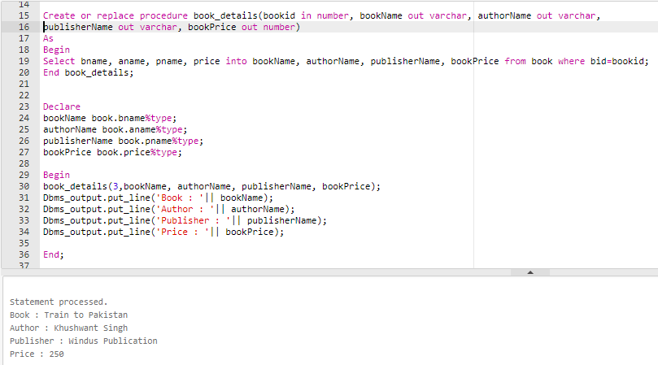

1. Write a procedure to find out total no of books written by a particular author.

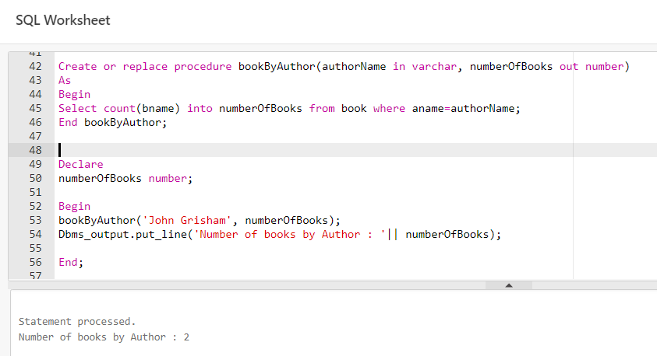

3. Write a procedure to count total number of publishers who are providing books to a library.

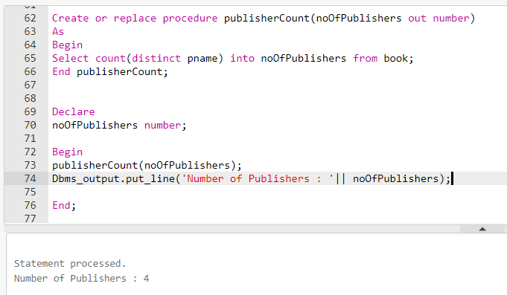

1. Write a procedure to update the price of books by 25 %, which are written by a particular author.

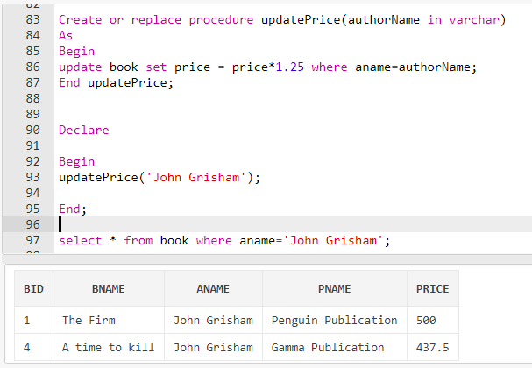

Lab Assignment – 5



1. Implement cursors to list name of employees with designation ‘Manager’.

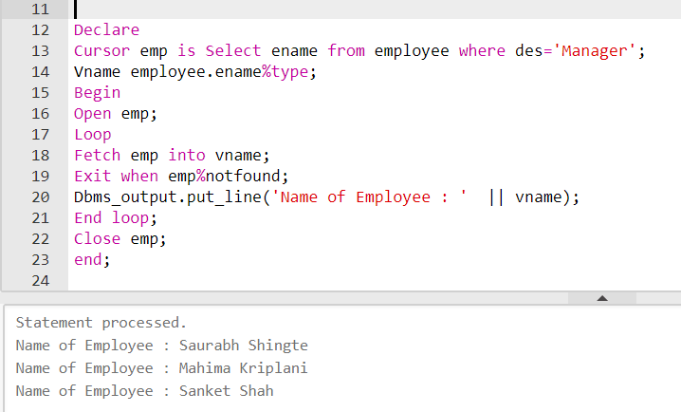

1. Print information of first five highest salary earners using cursors.

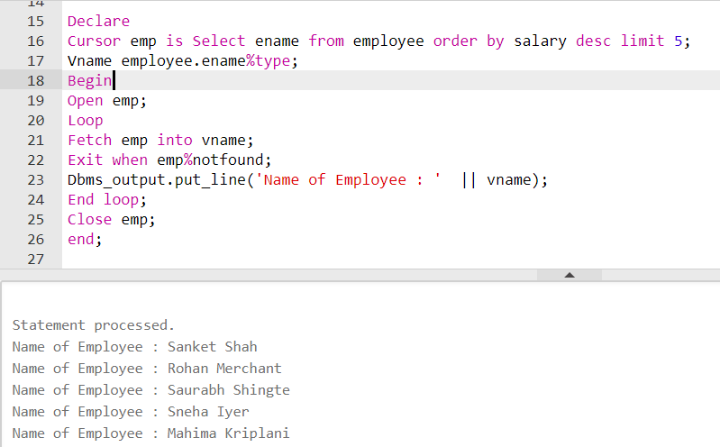

1. List name of employees working for more than 10 years using cursors.

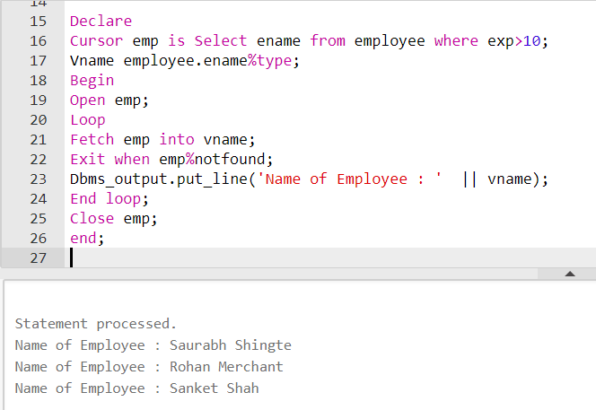

1. Find the person whose age is above 25 using cursors.

